**Rock Paper Scissors Prime Write Up**

**Noah Scott**

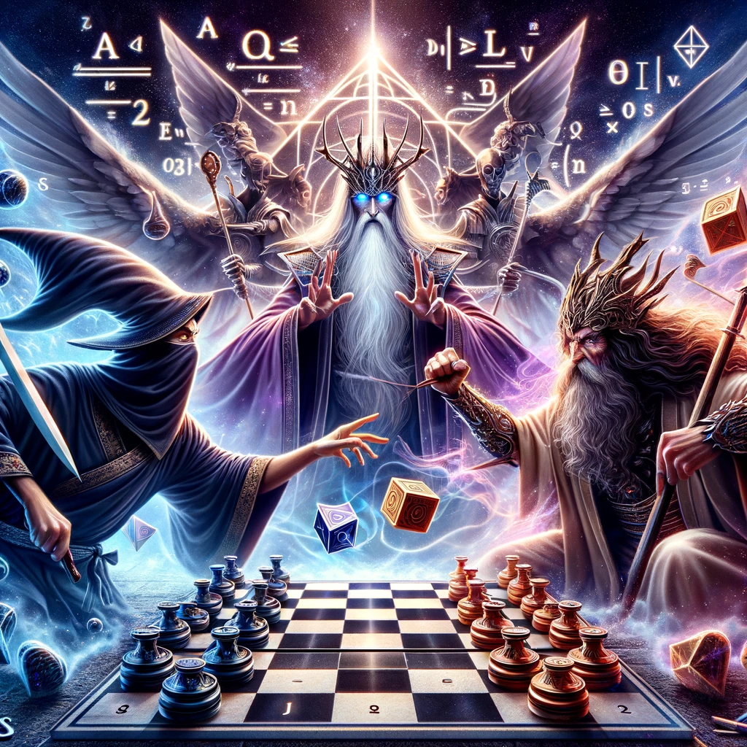

**Game Overview**

"Rock Paper Scissors Prime" (RPSP) is an innovative game that combines the classic Rock Paper Scissors with a strategic board game similar to checkers. The game is played on an 8x8 board with two players, each starting with 12 pieces. RPSP is treated as a turn based rpg duel with a health bar and damage. The twist comes with the inclusion of the "Prime" option in the Rock Paper Scissors element, adding a unique strategic layer to the game. If the prime counter within the RPSP duels is prime then the list of primes from 2 to that number will be multiplied to your damage and result in a powerful attack.

**Rules of the Game**

1. **Board Setup**: An 8x8 board with players' pieces placed on their respective sides.

2. **Player Moves**: Each player, in turn, moves a piece diagonally in an attempt to capture the opponent's pieces by "jumping" over them.

3. **Rock Paper Scissors Prime Duel**: When a capture is attempted, a Rock Paper Scissors Prime (RPSP) duel is initiated. The outcome of this duel determines if the capture is successful.

4. **Prime Mechanism**: If a player chooses "Prime" and the "Prime Counter" is at a prime number, it results in a powerful move.

5. **Winning the Game**: A player wins by capturing all of the opponent's pieces or blocking all possible moves.

**Implementation of Data Structures and Algorithms**

- **Lists**: Used to maintain a move history, enabling tracking of all moves made during the game.

- **Queues**: Implemented for managing the turn order of the players.

- **Sets**: Utilized in the AI's decision-making process to store potential choices based on the player's previous move.

- **Stacks**: Employed for the undo functionality, allowing players to revert moves.

- **Gameplay Algorithms**: The core game mechanics, including move validation, sieve of eratosthenes, capture logic, and the RPSP duel, are governed by specific algorithms ensuring the game adheres to its rules.

**Current Bugs and Issues**

1. **Invalid AI Jumps and Moves**: The AI sometimes performs non-valid jumps or captures its own pieces.

2. **Piece Count Inconsistencies**: Occasionally, pieces are incorrectly added or not removed as per the game rules.

3. **Undo Functionality**: The current undo feature has limitations and does not always revert the game state accurately.

**Future Improvements**

1. **Enhanced AI Logic**: Implementing more advanced algorithms like Minimax for AI decision-making could significantly improve its performance and adherence to game rules.

2. **Bug Fixes**: Addressing the current bugs in jump validation and piece counting will make the gameplay more consistent and fair.

3. **Optimizing Data Structures**: Refining the use of lists, queues, and stacks to manage game states and histories more efficiently.

4. **Graphs and Trees**: Using trees and graphs to map out possible moves and outcomes could enhance both AI capabilities and player experience.

**Conclusion**

"Rock Paper Scissors Prime" presents a unique blend of strategy and chance with its combination of classic and innovative gameplay elements. While the current implementation effectively utilizes various data structures and algorithms, there is room for improvement and optimization, especially in AI behavior and game mechanics consistency. Future iterations of the game will aim to address these areas, enhancing both the reliability and the strategic depth of the experience.